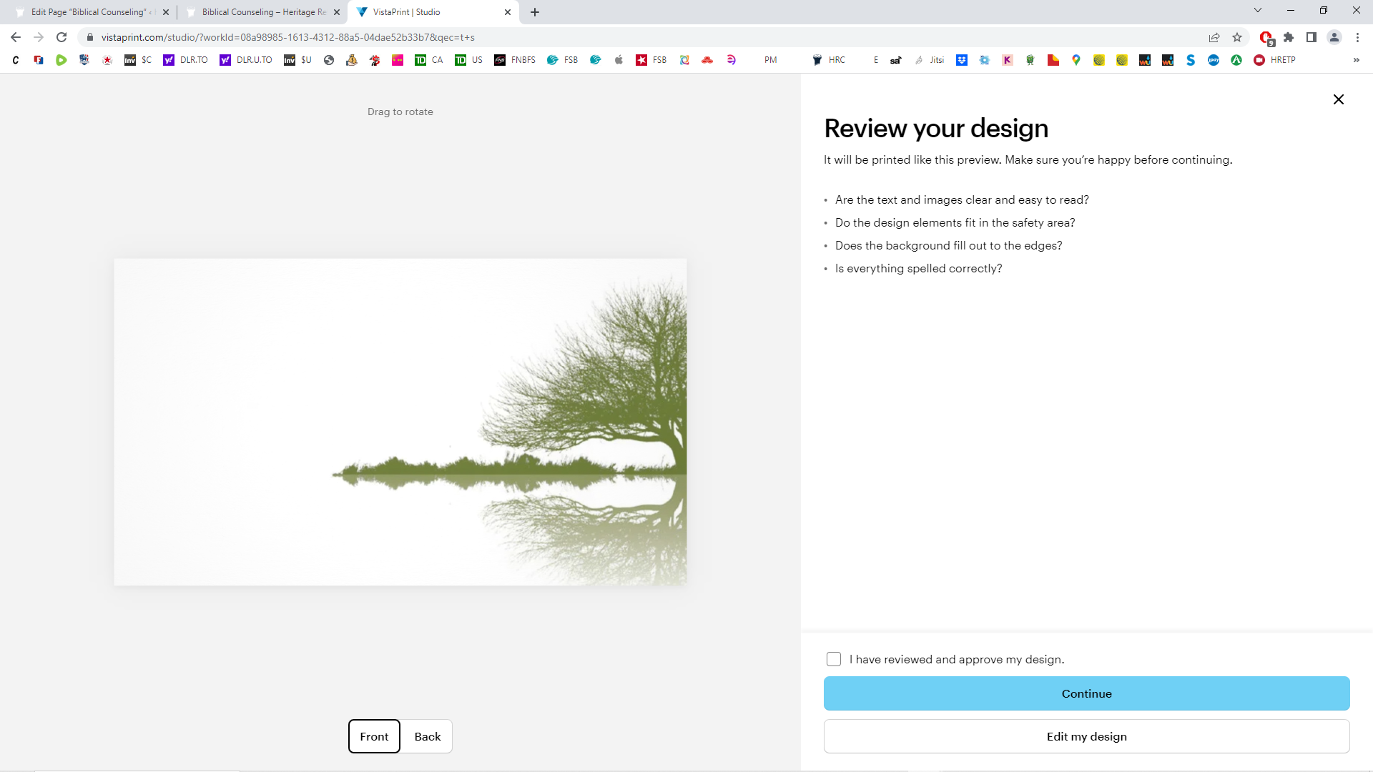
Conway Biblical Counseling Center

BIBLICAL COUNSELING AGREEMENT FORM

Services Disclaimer
Conway Biblical Counseling Center (CBCC) is a Christian not-for-profit organization offering counseling, information, emotional, and spiritual support, practical help, and referrals for professional services when needed.
Confidentiality Disclaimer
All information is held in confidence between the client and staff of CBCC unless we have discussed this with you and received your written consent. There are, however, certain circumstances in which we would be compelled to break confidentiality. These are:
- if we believe you are at risk of suicide
- if we believe you intend to harm another person
- if the health and safety of a child is at risk
- if a child is being or has been abused
In these cases, we have a legal obligation to report this information to the relevant authorities.
The information gathered on the Intake form is for our records and will not be given to third parties.
Client Responsibilities
Clients will agree to adhere to the following counseling ground rules:
- Be open and honest in your communication with the counselor.
- Complete “homework” before your appointment.
- Will try to arrive 5 minutes early for appointments.
- Give 24 hours notice if canceling or rescheduling appointments.
- Not be under the influence of drugs and alcohol at the time of your appointment.
You are not obligated to pay anything for our services but are free to make a donation to the center if you wish. Donations are not be tax-deductible as we are not a 501c3 organization.

I have read and understand the above.
Client Name: ________________________________________________
Parent/Guardian Name (if applicable): ____________________________
Client or Parent/Guardian signature: _____________________________
Date: ______________________________________________________
CBCC Staff Signature: ________________________________________

